**Queries & Outputs:**

1. Names and average prices of all categories whose average price is greater than 360

select Category, avg (Price)

from Book

group by Category

having avg (Price) > 360;

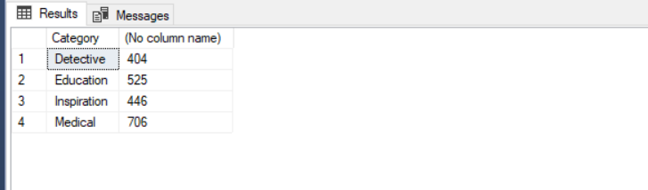

1. Average price of books in each category.

select Category, avg (Price) as avg_price

from Book

group by Category;

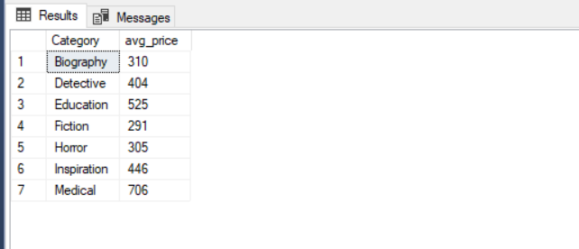

1. Total number of Issue books by students.

select count (*)

from Issue_book;

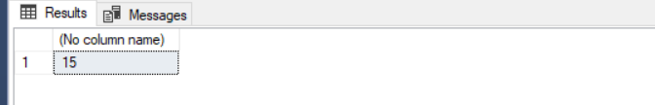

1. Total number of students who issued the books in the year of 2018.

select count(distinct Student_id)

from Issue_book

where (select Year(Issue_date)) = '2018';

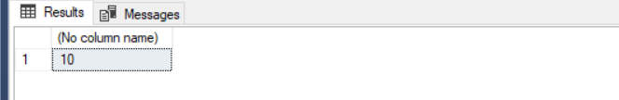

1. Average price of book in the DYD publication.

select avg (price)

from Book

where Publication= 'DYD';

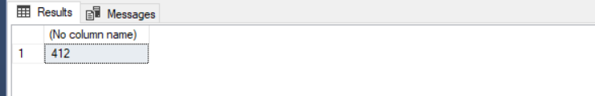

1. Minimum price of book.

select min (price)

from Book;

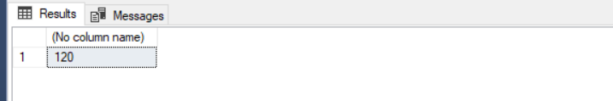

1. Students whose are not return their books.

select Student_id_

from Issue_book_

where Return_date is null;

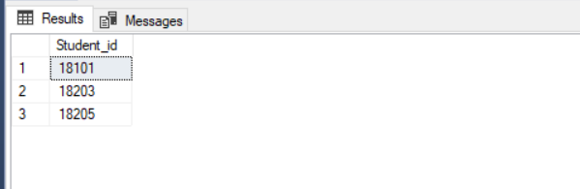

1. Maximum price of books in detective category.

select max (price)

from Book

where Category='detective';

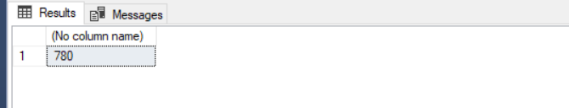

1. List in descending alphabetic order the names of all librarian.

select distinct Librarian_name

from Librarian

order by Librarian_name desc

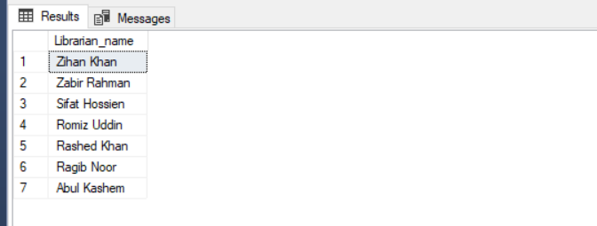

1. Names, contact number of all librarian who have sent some message and the message.

select Librarian_name,Cell_num,Message_

from Librarian, Email

where Librarian.Librarian_id=Email.Librarian_id;

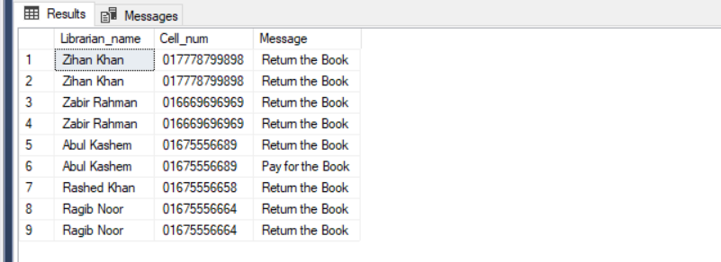

1. Names of all books where price is greater than the price of books in the fiction category.

select Book_name

from Book

where price > all (select Price

from Book

where Category = 'fiction');

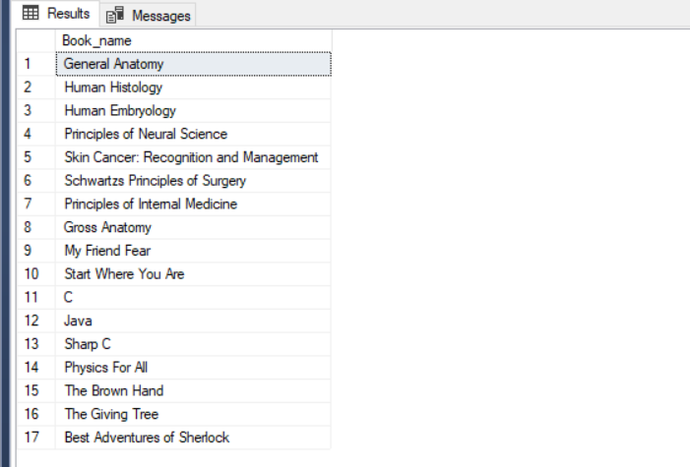

1. All categories where the total price of books is greater than the average of the total price at all categories.

with category_total (Category, value) as

(select Category, sum(Price)

from Book

group by Category),

category_total_avg(value) as

(select avg(value)

from category_total)

select Category

from category_total, category_total_avg

where category_total.value > category_total_avg.value;

